Build Adaptive Patterns using LLM :
PDF Invoices Parsers with Python, RegEx, Machine Learning, and Large Language Models

Automating the extraction of structured information from PDF documents has long been a challenge for developers, particularly in Accounts Payable workflows where invoices arrive from multiple vendors in completely different layouts. Despite significant progress in Data Science, Optical Character Recognition, and Machine Learning, the problem has not been fully solved. The fundamental issue is the absence of standardization. Each vendor designs invoices using its own structure, placing fields such as invoice numbers, dates, totals, and
tables in different positions and formats. Because of this variability, a single universal parsing logic cannot be applied reliably. Developers often end up rewriting scripts repeatedly for
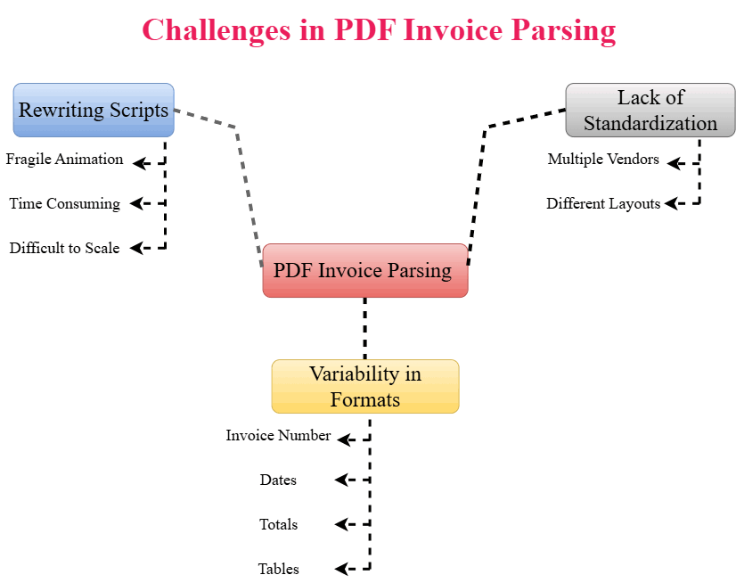
every new template, making automation fragile, time-consuming, and difficult to scale.

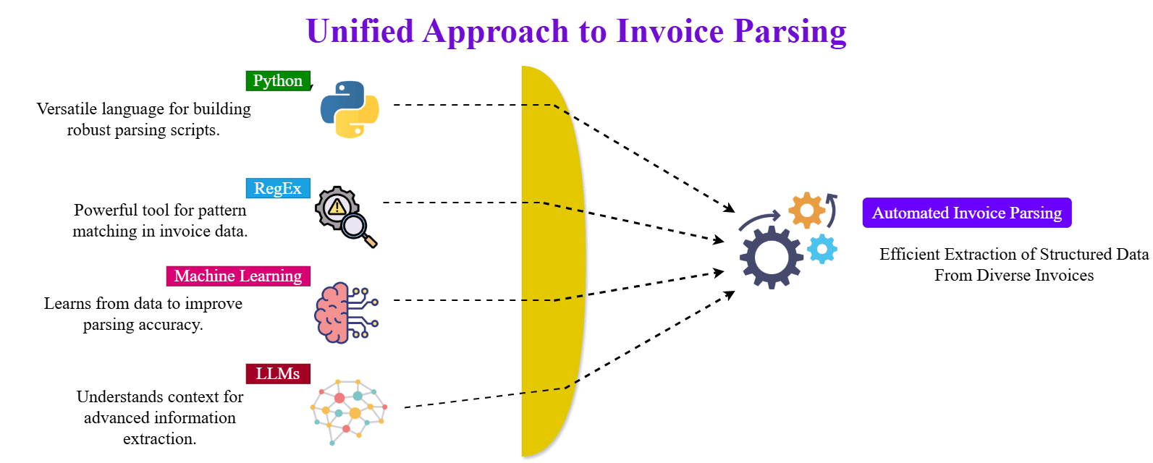

Historically, organizations relied on tools such as Tabula for table extraction, Robotic Process Automation for repetitive data entry, and rule-based techniques like Regular Expressions to capture known patterns. While these approaches work well for documents that follow consistent structures, they are highly sensitive to layout changes. Even small formatting adjustments can break the extraction logic and require manual reconfiguration. As
document diversity increases, maintaining template-specific rules becomes impractical and costly.
Regular Expressions introduced a more flexible alternative by focusing on textual patterns rather than fixed positions. Instead of depending on coordinates, pattern-driven logic identifies recognizable structures such as dates, numeric identifiers, and currency values.
This approach provides greater resilience against layout differences and allows predictable
elements to be extracted across multiple templates. For many years, RegEx has served as the backbone of semi-structured document parsing because it balances precision with
adaptability.

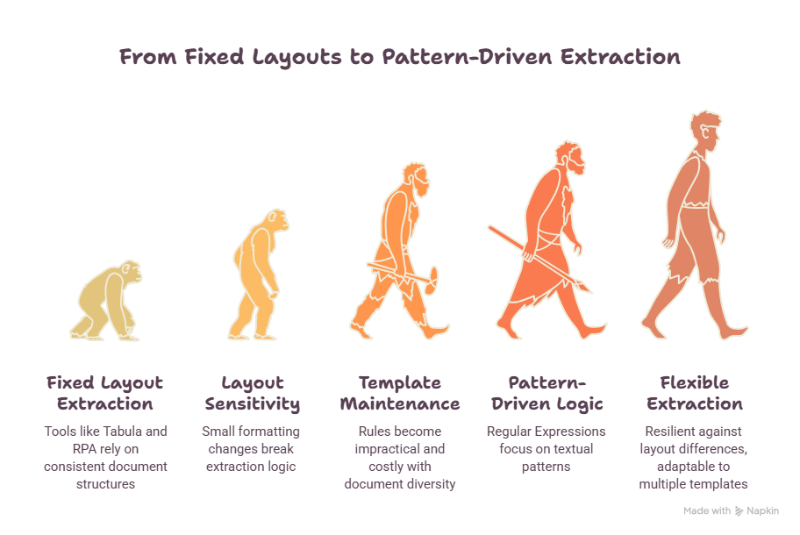

However, rule-based methods alone still have limitations. They can identify known formats but struggle when context or semantics are required. Variations in wording, unexpected
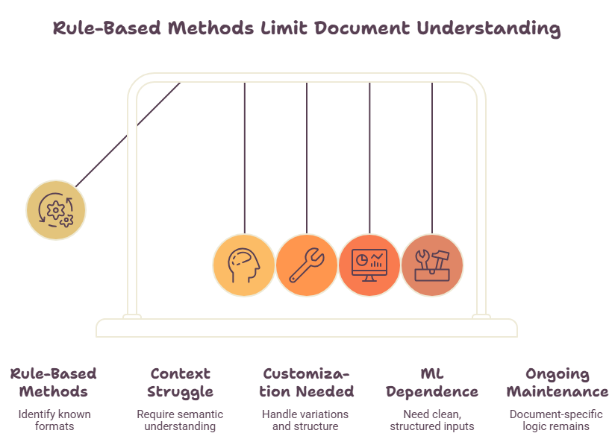
placements, or partially structured text often require additional customization. Machine Learning models were introduced to address these gaps, yet they still depend heavily on clean preprocessing and structured inputs. In practice, ML reduced some manual effort but did not eliminate the need for document-specific logic, leaving developers with ongoing maintenance challenges.
Large Language Models introduce a new level of intelligence to this process. Unlike traditional algorithms that rely strictly on predefined rules, LLMs understand text
contextually and can interpret both language and structure. They can read extracted
content, infer meaning, recognize relationships between fields, and adapt to unfamiliar layouts. Because LLMs operate on semantic understanding rather than rigid templates, a single generalized parsing strategy can be extended across a wide range of invoice formats. This transforms static scripts into adaptive systems that evolve with new documents instead of breaking.
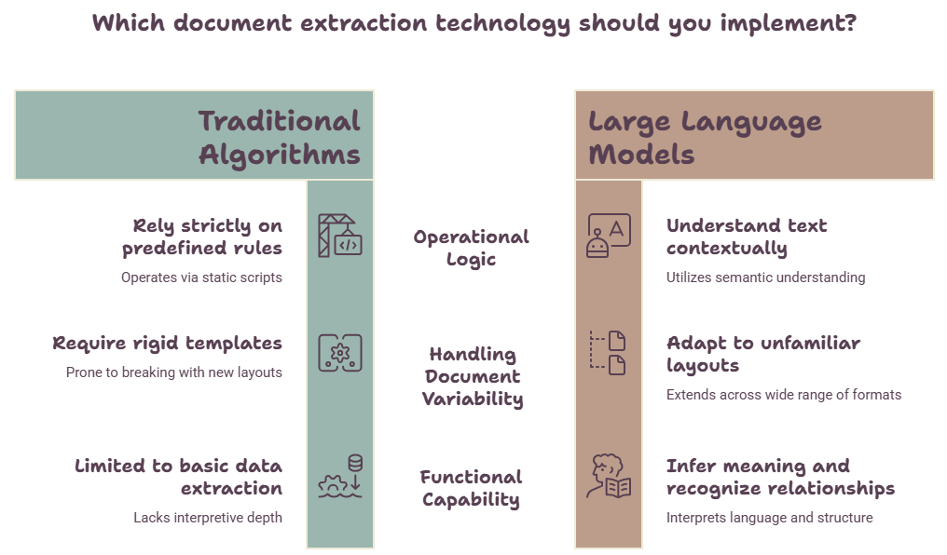

Beyond Traditional PDF Parsers: How LLMs Transform Rule-Based Extraction into Intelligent Document Processing
To leverage these strengths, an adaptive solution can be built in Python by combining PDF parsers, Regular Expressions, Machine Learning techniques, and Large Language Models. In this layered design, deterministic logic handles consistent patterns, while intelligent models interpret ambiguous or variable sections. The system extracts raw text from PDFs,
standardizes predictable elements using RegEx, and then applies ML or LLM reasoning to classify, validate, and structure the remaining information. The final output is converted into clean, usable datasets such as Excel or CSV, ready for downstream processes.

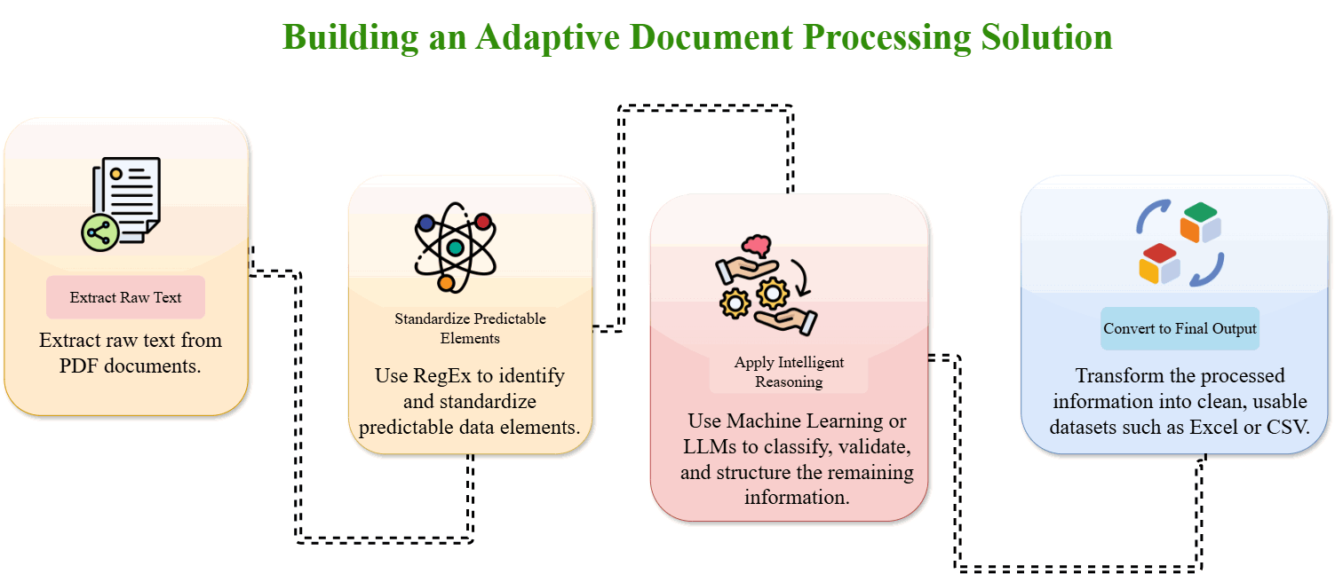

For Ex: Regular Expression PDF Parsing Coding

# Install required libraries
!pip install PyPDF2

import os
import PyPDF2 import pandas as pd import numpy as np import re

# Set your PDF path and working directory
file = r"C:\\PATH_TO_YOUR_PDF_FOLDER\\YOUR_PDF_FILE.pdf" dir_Path = r"C:\\PATH_TO_YOUR_PDF_FOLDER" os.chdir(dir_Path)

# Read PDF
pdf_file = open(file, 'rb')
read_pdf = PyPDF2.PdfFileReader(pdf_file) page = read_pdf.getPage(0)
page_content = page.extractText()
# Prepare data extraction
headers = ['Invoice', 'Credit_Cards', 'Delivery_Date', 'Due_Date', 'Original_Amount', 'Discount', 'Balance', 'Draft ed']
frames = []
table_list = page_content.split('\n') is_credit = False

for line in table_list:
if "CREDIT CARDS" in line or "CREDIT MEMOS" in line:
is_credit = True
newline = line.replace('-', '') found = re.search(
r'(\d+)\s+?(\s{6,}|\d{2}/\d{2}/\d{2})\s+(\d{2}/\d{2}/\d{2})*\s+([\d+,?]*.{1}\d{2})\s+([\d+,?]*.{1}\d{2})\s+([\ d+,?]+.{1}\d{2})\s+([\d+,?]+.{1}\d{2})',
newline
)
if found:
if is_credit:
updated_items = (np.nan,) + (found.groups()[0],) + tuple(found.groups()[2:3]) updated_items += ('-'+found.groups()[3],)
updated_items += (found.groups()[4],) updated_items += ('-'+found.groups()[5],) updated_items += ('-'+found.groups()[6],)
frames.append(pd.DataFrame(dict(zip(headers, list(updated_items))), index=[0])) else:
updated_items = (found.groups()[0],) + (np.nan,) + tuple(found.groups()[2:])
frames.append(pd.DataFrame(dict(zip(headers, list(updated_items))), index=[0]))

# Combine and export
df = pd.concat(frames)
df.to_csv('parsed_pdf.csv', index=False)

This hybrid architecture aligns with modern Intelligent Document Processing practices. OCR converts scanned documents into machine-readable text, Regular Expressions extract well-defined fields with precision, and ML or LLMs provide contextual interpretation and adaptability. By combining these components, organizations achieve both reliability and
flexibility, reducing manual corrections while improving scalability across diverse document types.
Integration with Intelligent Document Processing (IDP)
Modern Intelligent Document Processing systems benefit from a layered approach:
- OCR converts scanned documents into machine-readable text
- RegEx extracts well-defined structured fields
- ML/LLMs interpret context and handle ambiguity
This combination ensures high accuracy, flexibility, and scalability while reducing manual effort. By blending deterministic logic with probabilistic intelligence, organizations achieve robust and reliable automation.

In conclusion, traditional PDF parsing and standalone Machine Learning approaches struggle to cope with the structural variability of real-world invoices. Pattern-based extraction improves consistency but still requires maintenance when formats change. The introduction of Large Language Models fundamentally shifts this paradigm by enabling contextual
understanding and generalized parsing logic. By integrating RegEx, ML, and LLMs into a
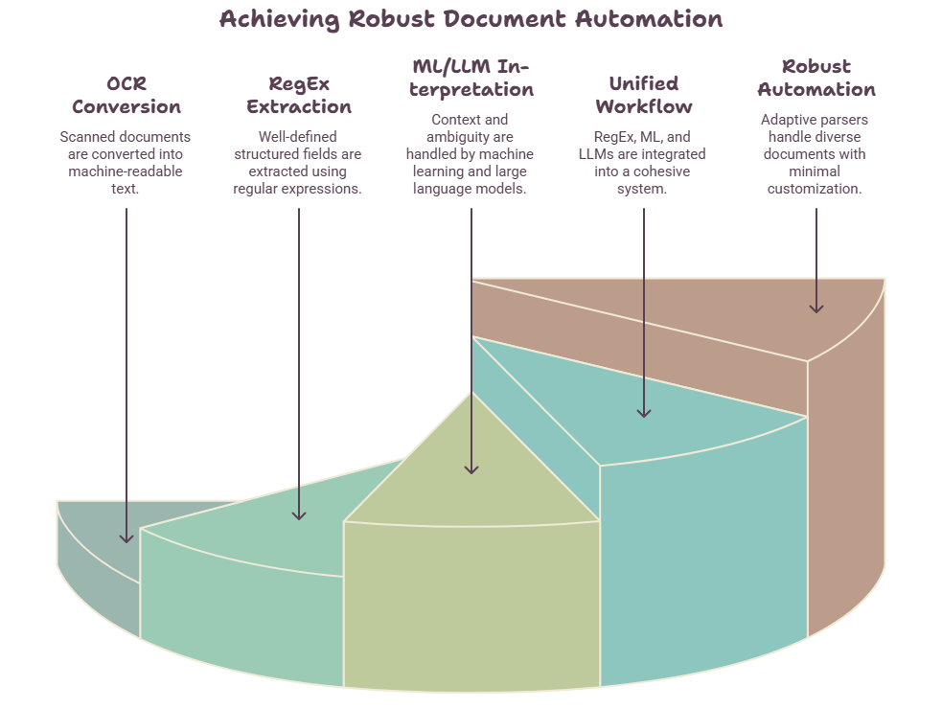
unified workflow, developers can build adaptive parsers that handle diverse PDF documents with minimal customization, making document automation more robust, scalable, and sustainable across enterprise environments

